Setup:

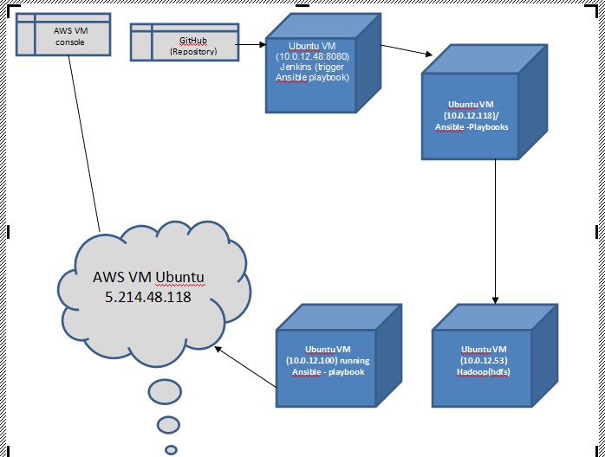

Ansible playbook for hadoop install:

  - VM IP ----- 10.0.12.118
  - VDI name -------- Ubuntu 14.04 LTS(64bit)

- (Local Instance)
  - VM IP ----- 10.0.12.53
  - VDI name -------- Ubuntu_14_04_Updated_VDI

Ansible Playbook for AWS ec2 instance creation:

- VM IP ----- 10.0.12.100
- VDI name ----- ansible_host

Jenkins Setup:

- VM IP ----- 10.0.12.48
- VDI Name ---- Ubuntu 14.04 LTS(64bit)-----vdi

Workflow Over-View:

- Committing the code in GitHub Repository.
- Jenkins will fetch the code from GitHub repository and create a WAR file out of it.
- Jenkins will push the WAR to the SFTP-server.
- Jenkins will trigger an Ansible playbook.
- Ansible will provision a ec2 instance on Public Cloud.
- Ansible will provision Apache Hadoop local instance

